- Certificates
  - Covering Page
  - College Certificate
  - Acknowledgement
  - Declaration
  - Abstract

- Introduction
  - Company Profile
  - Project
  - Overview

- Literature Survey
- System Analysis
  - Existing System
  - Proposed System
  - Feasibility Study
  - Project Planning with Graph
  - Software/ Hardware Requirements
  - Modules and its Description
  - Data Flow Diagrams

- Software Requirement Specifications
  - Introduction
    - Scope
    - Purpose
    - Objective
    - Definitions, Acronyms and Abbreviations
    - References
    - Overview
    - Tools

- System Design
  - Input Design
  - Output Design
  - UML Diagrams
  - Data Dictionary

- Implementation
  - Methodology
  - Technologies Used

- Testing
  - Introduction
  - Test Cases
- Maintenance
- Future Enhancement
- Conclusion
- Bibliography
- Screens/ Forms

Efficient Broadcasting with Guaranteed Coverage in MANETs

Dissertation submitted in partial fulfillment of the requirements for the award of degree
Of

Course Name

By

Name of the Student
(Roll No)



University Name
City
Year

College Certificate

This is to certify that the dissertation entitled “Efficient Broadcasting with Guaranteed Coverage in MANETs” that is being submitted by “Student Name”, a student of “Course Name” in the “College address with department”, during the period of “year” in partial fulfillment for the award of the “Course”. It is a record of bonafied work carried out by them under our guidance and supervision.

The result embodied in this project have not been submitted to any other University or Institute for the award any degree or diploma.

INTERNAL EXAMINER EXTERNAL EXAMINER

HEAD OF THE DEPARTMENT

ACKNOWLEDGEMENT

I thank this opportunity to thank all those individuals, without those help this project have been incomplete.

I thank to the organization “Company Name” for having confidence in me and making use of my activities by offering this project.
I would like to thank “Director Name” Director of College Name, Address. I would like to express my deep sense of gratitude to all my LECTURERS for giving Valuable suggestions during my project and I sincerely thanks to my COLLEGE LIBRARY.
My profound gratitude goes to “Guide Name”, “Company Name”, as a project guide for guiding me in right way and helped me in this project. I would also express my sincere thanks to persons who are helpful in explaining about needed Domain Information of the Existing System.
Last but not least a grateful thanks to my PARENTS and my FRIENDS and also the PERSONS who supported me directly and indirectly during the Project.

(Name of the Student)

DECLARATION

I hereby declare that the project work titled “Efficient Broadcasting with Guaranteed Coverage in MANETs” submitted to the “College Name”. College affiliated to “Name of University”, as a partial fulfillment for the award of “Course Name”. This is an original work done by me and has not been submitted to any other Institution.

PLACE: (Student Name)

DATE:

1.5. ABSTRACT:

We study an efficient broadcast scheme in mobile ad hoc networks (MANETs). The objective is to determine a small set of forward nodes to ensure full coverage. We first study several methods that guarantee coverage when the local view of each node on its neighborhood information is updated in a timely manner. Then we consider a general case where nodes move even during the broadcast process, making it impractical to maintain up-to-date and consistent local views.
A formal framework is used to model inaccurate local views in MANETs, where full coverage is guaranteed if three sufficient conditions,
Connectivity, link availability, and consistency, are met.
Three solutions are proposed to satisfy those conditions. First, we give a minimal transmission range that maintains the connectivity of the virtual network constructed from local views. Then, we use two transmission ranges, one for neighborhood information collection and the other for actual data transmission, to form a buffer zone that guarantees the availability of logical links in the physical network. Finally, we propose a mechanism called aggregated local view to ensure consistent local views. By these, we extend Wu and Dai’s coverage condition for broadcasting in a network with mobile nodes
2.0. INTRODUCTION

  - Company Profile:

“Organization Name” Software Solutions is an IT solution provider for a dynamic environment where business and technology strategies converge. Their approach focuses on new ways of business combining IT innovation and adoption while also leveraging an organization’s current IT assets. Their work with large global corporations and new products or services and to implement prudent business and technology strategies in today’s environment.

“ORGANIZATION NAME” RANGE OF EXPERTISE INCLUDES:
- Software Development Services
- Engineering Services
- Systems Integration
- Product Development
- Electronic Commerce
- Consulting
- IT Outsourcing
We apply technology with innovation and responsibility to achieve two broad objectives:
- Effectively address the business issues our customers face today.
- Generate new opportunities that will help them stay ahead in the future.

THIS APPROACH RESTS ON:
- A strategy where we architect, integrate and manage technology services and solutions - we call it AIM for success.
- A robust offshore development methodology and reduced demand on customer resources.
- A focus on the use of reusable frameworks to provide cost and times benefits.
They combine the best people, processes and technology to achieve excellent results - consistency. We offer customers the advantages of:

SPEED:
They understand the importance of timing, of getting there before the competition. A rich portfolio of reusable, modular frameworks helps jump-start projects. Tried and tested methodology ensures that we follow a predictable, low - risk path to achieve results. Our track record is testimony to complex projects delivered within and evens before schedule.

EXPERTISE:
Our teams combine cutting edge technology skills with rich domain expertise. What’s equally important - they share a strong customer orientation that means they actually start by listening to the customer. They’re focused on coming up with solutions that serve customer requirements today and anticipate future needs.

SERVICES:
“Organization Name” is providing its services to companies which are in the field of production, quality control etc., with their rich expertise and experience and information technology they are in best position to provide software solutions to distinct business requirements.

  - Project Introduction

BROADCASTING a packet to the entire network is a basic operation and has extensive applications in mobile ad hoc networks (MANETs). For example, broadcasting is used in the route discovery process in several routing protocols, when advising an error message to erase invalid routes from the routing table, or as an efficient mechanism for reliable multicast in a fast-moving MANET. In MANETs with the promiscuous receiving mode, the traditional blind flooding incurs significant redundancy, collision, and contention, which is known as the broadcast storm problem. Efficient broadcasting in a MANET focuses on selecting a small forward node set while ensuring broadcast coverage.

  - Overview

Broadcast protocols can be classified into deterministic and probabilistic approaches.
The probabilistic approach usually offers a simple solution in which each node, upon receiving a broadcast packet, forwards the broadcast message with probability p. However, the probabilistic approach cannot guarantee full coverage.
The deterministic approach guarantees full coverage
This can be further classified based on the type of neighborhood information used:
- Location-information-based
- Neighborset- based
In location-information-based broadcast protocols, location information of neighbors is available, whereas in neighbor-set-based broadcast protocols, only neighbor set information is available.
Location information facilitates efficient broadcasting in terms of generating a small forward node set; however, it comes with a cost—location information requires additional hardware.
Other types of information can also be used which fall in between the above two models: directional information, where messages arrive from a certain angle-of-arrival (AOA), and distance information based on the signal strength received. All these models assume some sort of special hardware. In addition, location/direction/distance information may not be accurate.
This project, we limit our consideration to deterministic broadcast protocols that use neighbor set information only, which corresponds to the weakest assumption on neighborhood information used. In a broadcast process, each node decides its forwarding status based on given neighborhood information (such information is constructed from the neighbor set of each node), and the corresponding broadcast protocol is called self-pruning. In figure 1 black (white) nodes are forward (non forward) nodes. Each circle corresponds to a one-hop neighborhood.
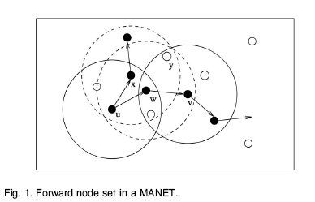
Any source node is a black node by default. Basically, forward nodes form a connected dominating set (CDS), where each node in the system is either in the set or the neighbor of a node in the set. That is, each white node has at least one black neighbor. However, most existing broadcast schemes assume either the underlying network topology is static or quasi-static during the broadcast process such that the neighborhood information can be updated in a timely manner. The results in existing static network broadcast schemes perform poorly in terms of delivery ratio when nodes are mobile. There are two sources that cause the failure of message delivery Collision. The message intended for a destination collides with another message. In Fig. 1, if messages from nodes w and x collide at node y, node y does not receive any message. Mobile nodes. A former neighbor moves out of the transmission range of the current node (i.e., it is no
longer a neighbor). In Fig. 1, when node w moves out of the transmission range of u, the nodes along the branch rooted at w of the broadcast tree will miss the message.1
Results in show that the effect of collision can be relieved by a very short (1ms) forward jitter delay, where a very high ( 99 percent) delivery ratio is achieved in static
networks. The majority of delivery failures are caused by mobile nodes. Therefore, in this paper, we focus on delivery failures caused by mobility only.
The major challenges in designing a localized broadcast protocol while ensuring broadcast coverage are as follows:
- The network topology changes over time, even during the broadcast process.
- The local (1-hop) information is constructed based on “Hello” intervals. To avoid serious collision among “Hello” messages, nodes start their intervals asynchronously, making it difficult to ensure consistent local/global views among nodes.
- The collection process for k-hop information incurs delay which may not reflect the current network topology when there are mobile nodes, even for a small k in localized solutions.
As a consequence, the virtual network constructed from local views of nodes may not be connected (connectivity issue), its links may not exist in the physical network (link availability issue), and the global view constructed from the collection of
local views may not be consistent (consistency issue). In this paper, we first give a sufficient condition for connectivity at the physical network to ensure the connectivity
at the virtual network. We then propose a solution using two transmission ranges to address the link availability issue. The neighborhood information, as well as the
forward node set, are determined based on a short transmission range, whereas the broadcast process is done on a long transmission range. The difference between these
two ranges is based on the update frequency and the speed of node movement. The difference is also used as a new controllable parameter to balance broadcast redundancy and broadcast delivery ratio. Although many deterministic broadcast protocols have been proposed with different broadcast redundancies (and collated broadcast delivery
ratios), each broadcast protocol has only its “fixed” broadcast redundancy (and broadcast delivery ratio). It is, in general, hard to control redundancy and delivery for a given broadcast protocol. Note that the forwarding probability in probabilistic broadcasting is is also a controllable parameter. However, it is difficult to establish a direct connection between parameter selection and node mobility. Finally, we propose a new mechanism called aggregated local view to ensure consistency of the global view.
The conservative approach aggregates past k local views in a special way to eliminate potential view inconsistency caused by asynchronous “Hello” intervals and collection process delay for k-hop information at each node.

This project concentrates on the deterministic approach. This guarantees the full coverage in mobile adhoc network. This uses deterministic broadcast protocols that use neighbor set information only, which is more efficient method.
The main contributions of this paper are as follows:
- Propose the first localized broadcast protocol that can handle node mobility while ensuring broadcast coverage.
- Systematically address the issue of inconsistent local view caused by neighborhood information delay, asynchronous “Hello” intervals, and node mobility.
- Introduce a new controllable parameter to balance broadcast efficiency and broadcast delivery ratio.
- Conduct a simulation study to verify the effectiveness of the new approach.

The project is designed with Visual Basic . Net. The user screen designed to get Node count and provisions were given to invoke the Single Neighborset Routing and Dual Neighborset Routing algorithm. Finally with help of simulation comparisons results were displayed on the frame.

3.0. LITERATURE SURVEY

A mobile ad hoc network (MANET), sometimes called a mobile mesh network, is a self-configuring network of mobile devices connected by wireless links.
Each device in a MANET is free to move independently in any direction, and will therefore change its links to other devices frequently. Each must forward traffic unrelated to its own use, and therefore be a router. The primary challenge in building a MANET is equipping each device to continuously maintain the information required to properly route traffic.
Such networks may operate by themselves or may be connected to the larger Internet.
MANETs are a kind of wireless ad hoc networks that usually has a route able networking environment on top of a Link Layer ad hoc network. They are also a type of mesh network, but many mesh networks are not mobile or not wireless.
The growth of laptops and 802.11/Wi-Fi wireless networking have made MANETs a popular research topic since the mid- to late 1990s. Many academic papers evaluate protocols and abilities assuming varying degrees of mobility within a bounded space, usually with all nodes within a few hops of each other and usually with nodes sending data at a constant rate. Different protocols are then evaluated based on the packet drop rate, the overhead introduced by the routing protocol, and other measures.
  - SYSTEM ANALYSIS

System analysis can be defined, as a method that is determined to use the resources, machine in the best manner and perform tasks to meet the information needs of an organization.
System Description
It is also a management technique that helps us in designing a new systems or improving an existing system. The four basic elements in the system analysis are
- Output
- Input
- Files
- Process
The above-mentioned are mentioned are the four basis of the System Analysis.
Proposed System
The proposed system based on mobility management and, in particular, neighbor set management in a mobile environment. The broadcast protocols in MANETs based on self-pruning.
A self-pruning protocol is static if it does not use visited node information in the coverage condition; otherwise, it is dynamic. In a static protocol, forward nodes are predetermined before any broadcast process and are source independent. For example, node w in Fig. 2a is a forward node in a static protocol because there is no replacement path to connect neighbors x and y. When node v is the source, there are actually three forward nodes v, w, and y. In a dynamic protocol, the forward status is determined during the broadcast process. Each node usually determines its status after a short back off delay when the node receives the packet for the first time. During the back off delay, more neighbors may forward the same broadcast packet and those neighbors become visited nodes. Each broadcast packet carries a list of recently visited nodes and each node uses the visited node information to enhance the chance of being pruned. The number of forward nodes is usually smaller than in a static protocol, but the selection of forward nodes is usually source dependent. Fig. 2b shows the broadcast process in the same network and with the same source node as in Fig. 2a. This time, node w is a non forward node because nodes x and y are connected via node v, which is known by w as a visited node (such information is piggybacked with the broadcast packet). There are only two forward nodes v and y. It is assumed that local views of the broadcast specific information (i.e., visited node information) are dynamic but safe, i.e., an unvisited node will not be mislabeled as visited and those of the broadcast independent information (i.e., k-hop information and priority) are “static” and accurate during a broadcast process. However, in mobile networks, such “static” information usually changes and causes inaccurate local views. Based on these inaccurate views, full coverage (i.e., 100 percent delivery ratio) is not guaranteed. Recently, we conducted a simulation study on the performance of the coverage condition and its special cases Simulation results show that most efficient broadcast protocols suffer from a low delivery ratio in highly mobile networks.
This proposed method maintains a mobility control method that addresses connectivity, link availability, and consistency issues.
Three sufficient conditions are given:
- the first one on the connectivity of the physical network to ensure connectivity of the virtual network,
- the second one on the bound of the range difference to ensure link availability,
and the third one on the consistent local views to ensure correct decision made at each node .
To meet these conditions the following methods are employed.
Logical Network and Broadcast State
The coverage condition was applied on a static or quasi-static physical network. In a quasi-static physical network, the physical topology stops to change several
“Hello” intervals before a broadcast process and stays unchanged until the broadcast process completes. For the sake of clarity, we assume node id is used as priority.
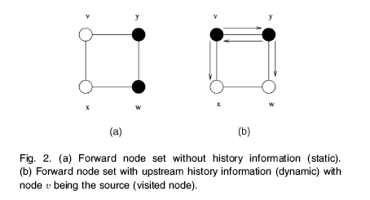
Two Levels of Abstraction studied in this project for the correctness of the coverage condition is based on the assumption that the local view is an accurate and immediate reflection of the physical topology. In MANETs, however, this assumption can be easily invalidated due to the continuous node mobility. In fact, in order to apply the coverage condition on MANETs with potentially outdated local views, we introduce the concepts of logical network, a dynamic virtual network constructed from all local views, broadcast state, a snapshot of local views during a broadcast process, and two levels of abstraction, as shown in Fig. 4:

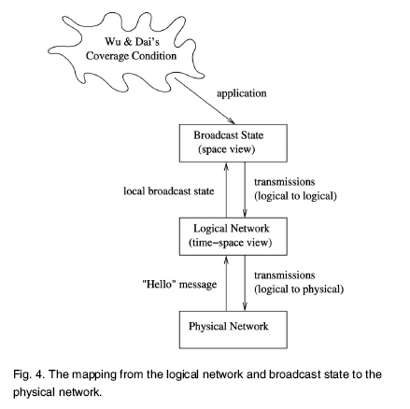
- Level-1 abstraction: from physical network (timespace view) to logical network (time-space view).
- Level-2 abstraction: from logical network (timespace view) to broadcast state (space view).
A logical network is the collection of all local views, i.e., a supergraph containing all the nodes and links in local views.
Both local view and logical network are time sensitive. When the physical topology changes, the change is detected by “Hello” messages and reflected in the logical network. Consider the MANET in Fig. 5a.
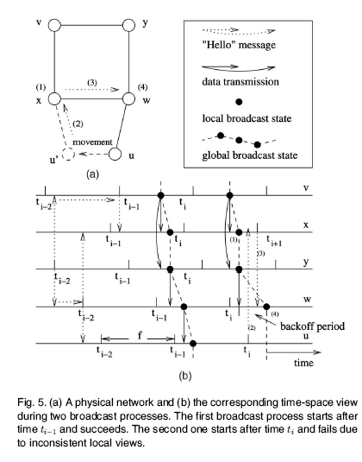

We assume that each node has the same “Hello” interval f² but each node starts its period asynchronously. Fig. 5b shows the update of local views. We label the time each node sends its last “Hello”

message before the broadcasting as t_{i}, the time for previous “Hello” messages as t_{i-1};
t_{i-2,} and so on. Note that t_{i} at each node may refer to different physical time. Here each node builds 2-hop information. If node y0 “Hello” message is first received by node v between t_{i-2,} and t_{i-1} (the “Hello” message propagation is shown in a dotted arrow line), it is added to v0s 1-hop neighbor set, which is advertised in v’s next “Hello” message at t_{i-1} That is, link (v,p) is added to local views of nodes v and x. Similarly, link (w,y) is also detected and added to local views of nodes u, w, and x. Broadcast state is a snapshot of local views of the logical network. For a specific broadcast process, broadcast state forms a virtual static network, upon which the coverage condition is applied.
The sufficient conditions can be applied to the global broadcast state and ensures coverage, given that the following three conditions are met:
connectivity, link availability, and consistency.
The first two conditions resolve the gaps at level 1 and level 2 abstractions, respectively.
The third condition ensures the consistent use of local views.
Connectivity refers to the virtual network that corresponds to the global broadcast state should be connected in order to apply our sufficient coverage condition.

Link availability refers to any link in the global broadcast state should still exist in the physical network during the broadcast period. We propose to use two transmission
ranges, r1 and r2, with r1 < r2.
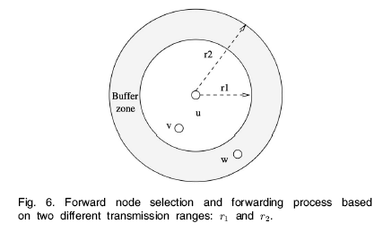
r1 is used to collect neighbor set and k-hop information through “Hello” messages, whereas r2 is used to perform actual transmission. A node
that is within the range of r1 of node u is called a neighbor of u and the collection of such nodes is the neighbor set of u. The set of nodes that are reachable based on r2 is called
effective neighbor set. Fig. 6 shows the relationship between these two transmission ranges.

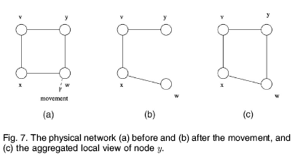
Consistency refers the two local views (or states for a specific broadcasting) of nodes u and v are inconsistent, if a link (v,w) exists in u’s local view (state), but v does not view w as a 1-hop neighbor.

In the implementation point Simulations are conducted to evaluate the proposed
method and explore appropriate source and destination message transmission ranges that achieve high delivery ratio with low broadcast redundancy under various mobility levels. We also evaluate the effectiveness of two implementation options that use dual neighbor sets to improve the delivery ratio under various environments.

  - Existing System

The existing methods in Broad casting follow the protocols which suffer from the following drawbacks:
- Probabilistic approach cannot guarantee full coverage
- Neighbor set information not accurate
- Static network broadcast schemes perform poorly in terms of delivery ratio when nodes are mobile.
- There are two sources that cause the failure of message delivery Collision.
- The messages from nodes w and x collide at node y, so node y does not receive any message.
- Mobile nodes, a former neighbor moves out of the transmission range of the current node
Due to these reasons the broad casting protocol in mobile network may not result in accurate result.

  - Proposed System

The proposed system based on mobility management and, in particular, neighbor set management in a mobile environment. The broadcast protocols in MANETs based on self-pruning. The major task is of Mobility Management where, the capacity of MANETs is constrained by the mutual interference of concurrent transmissions between nodes. The mobility of nodes adds another dimension of complexity in the mutual interference.
Broadcast Protocols Based on Self-Pruning, which helps in a MANETS. This is modeled as an undirected graph G = (V, E) where V is a set of mobile nodes and E is a set of wireless links. A link exists between two nodes u and v if and only if their physical distance is less than a transmission range r. The proposed efficient broadcast protocol based on self-pruning. In a self-pruning protocol, each node determines its forwarding status based on its local k-hop information, where k = 2 or 3.
This proposed method maintains a mobility control method that addresses connectivity, link availability, and consistency issues.
Three sufficient conditions are given:
- the first one on the connectivity of the physical network to ensure connectivity of the virtual network,
- the second one on the bound of the range difference to ensure link availability, and the third one on the consistent local views to ensure correct decision made at each node

  - Feasibility Study

The feasibility of the project is analyzed in this phase and business proposal is put forth with a very general plan for the project and some cost estimates. During system analysis the feasibility study of the proposed system is to be carried out. This is to ensure that the proposed system is not a burden to the company. For feasibility analysis, some understanding of the major requirements for the system is essential.
Three key considerations involved in the feasibility analysis are
- ECONOMICAL FEASIBILITY
- TECHNICAL FEASIBILITY
- SOCIAL FEASIBILITY

Economical Feasibility:
This study is carried out to check the economic impact that the system will have on the organization. The amount of fund that the company can pour into the research and development of the system is limited. The expenditures must be justified. Thus the developed system as well within the budget and this was achieved because most of the technologies used are freely available. Only the customized products had to be purchased.

Technical Feasibility:
This study is carried out to check the technical feasibility, that is, the technical requirements of the system. Any system developed must not have a high demand on the available technical resources. This will lead to high demands on the available technical resources. This will lead to high demands being placed on the client. The developed system must have a modest requirement, as only minimal or null changes are required for implementing this system.
Social Feasibility:
The aspect of study is to check the level of acceptance of the system by the user. This includes the process of training the user to use the system efficiently. The user must not feel threatened by the system, instead must accept it as a necessity. The level of acceptance by the users solely depends on the methods that are employed to educate the user about the system and to make him familiar with it. His level of confidence must be raised so that he is also able to make some constructive criticism, which is welcomed, as he is the final user of the system

  - Project Planning with Graph

  - Software/ Hardware Requirements

Hardware specifications:
Processor : Pentium IV 2.4GHZ
RAM : 512 MB
Hard disk : 40 GB
Software Specification
- Operating system : Windows XP Professional
- Technology : Microsoft Visual Studio .Net 2008
- Coding Language : VB.Net

  - Modules and its Description:

This project contains 3 modules. They are:

- Node addition and Mobility Creation
- Single and Dual neighbor set routing
- Comparison routing

Module Description:
- Node addition and Mobility Creation
The simulated model creates the cellular region and According to the Node count the nodes are placed in the cellular region for proposed system study. The static neighbor set algorithm is invoked by selecting the source and destination.
- Single and Dual neighbor set routing
Each node determines its forwarding status based on its local single neighbor set information. Based on next single neighbor set information is forwarded to link the virtual network based on link availability. The directed graph is designed to model this network and nodes in the directed graph represents mobile node and vertex of graph represents the connectivity established between nodes. So to implement the algorithm in program point of view Directed graph concept is used.
Each node determines its forwarding status based on its local Dual neighbor set information. Based on next two different neighbor set information is forwarded to link the virtual network based on link availability. The same concept above mentioned is called with this input. Result is displayed in the adjacent frame.

- Comparison routing
The result of the above mentioned algorithm is compared in the following three properties
  - Link
  - Connectivity
  - And Availability
The separate class is written that invokes the two methods and compares the properties. The efficiency ratio is displayed to the user. The efficiency of the delivery is found to be 99% in this simulated mobile adhoc network.

  - Data Flow Diagrams

A data flow diagram is graphical tool used to describe and analyze movement of data through a system. These are the central tool and the basis from which the other components are developed. The transformation of data from input to output, through processed, may be described logically and independently of physical components associated with the system. These are known as the logical data flow diagrams. The physical data flow diagrams show the actual implements and movement of data between people, departments and workstations. A full description of a system actually consists of a set of data flow diagrams. Using two familiar notations Yourdon, Gane and Sarson notation develops the data flow diagrams. Each component in a DFD is labeled with a descriptive name. Process is further identified with a number that will be used for identification purpose. The development of DFD’S is done in several levels. Each process in lower level diagrams can be broken down into a more detailed DFD in the next level. The lop-level diagram is often called context diagram. It consists a single process bit, which plays vital role in studying the current system. The process in the context level diagram is exploded into other process at the first level DFD.

DFD SYMBOLS:
In the DFD, there are four symbols
- A square defines a source(originator) or destination of system data
- An arrow identifies data flow. It is the pipeline through which the information flows
- A circle or a bubble represents a process that transforms incoming data flow into outgoing data flows.
- An open rectangle is a data store, data at rest or a temporary repository of data

Process that transforms data flow.

Source or Destination of data
Data flow

Data Store

CONSTRUCTING A DFD:
Several rules of thumb are used in drawing DFD’S:

- Process should be named and numbered for an easy reference. Each name should be representative of the process.
- The direction of flow is from top to bottom and from left to right. Data traditionally flow from source to the destination although they may flow back to the source. One way to indicate this is to draw long flow line back to a source. An alternative way is to repeat the source symbol as a destination. Since it is used more than once in the DFD it is marked with a short diagonal.
- When a process is exploded into lower level details, they are numbered.
- The names of data stores and destinations are written in capital letters. Process and dataflow names have the first letter of each work capitalized

A DFD typically shows the minimum contents of data store. Each data store should contain all the data elements that flow in and out.
Questionnaires should contain all the data elements that flow in and out. Missing interfaces redundancies and like is then accounted for often through interviews.

SAILENT FEATURES OF DFD’S
- The DFD shows flow of data, not of control loops and decision are controlled considerations do not appear on a DFD.
- The DFD does not indicate the time factor involved in any process whether the dataflow take place daily, weekly, monthly or yearly.
- The sequence of events is not brought out on the DFD.
Data flow diagram:
Adding mobile users
Selecting source and destination to establish connection
Choosing hoping
Single,checking one neighbour node
Dual,checking two neighbour nodes
Comparison of single and dual method

Data Flow Diagram:

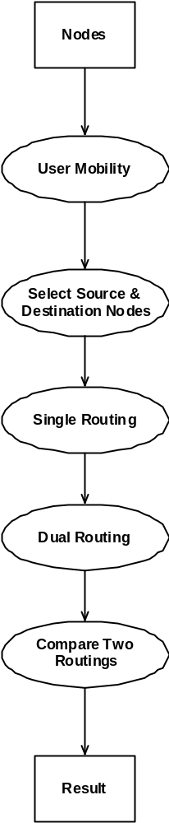

5.0. SOFTWARE REQUIREMENT SPECIFICATIONS

  - Introduction

    - Scope:

The scope of the project is to determine a small set of forward nodes to ensure full coverage. We first study several methods that guarantee coverage when the local view of each node on its neighborhood information is updated in a timely manner.

    - Purpose:

We consider a general case where nodes move even during the broadcast process, making it impractical to maintain up-to-date and consistent local views.

    - Objective

Broadcasting a packet to the entire network is a basic operation and has extensive applications in mobile ad hoc networks (MANETs).

    - Definitions, Acronyms and Abbreviations

Point-to-point:

The simplest topology is a permanent link between two endpoints (the line in the illustration above). Switched point-to-point topologies are the basic model of conventional telephony. The value of a permanent point-to-point network is the value of guaranteed, or nearly so, communications between the two endpoints. The value of an on-demand point-to-point connection is proportional to the number of potential pairs of subscribers, and has been expressed as Metcalfe's Law.

Bus:

Bus network topology
In local area networks where bus technology is used, each machine is connected to a single cable. Each computer or server is connected to the single bus cable through some kind of connector. A terminator is required at each end of the bus cable to prevent the signal from bouncing back and forth on the bus cable.

Star

Star network topology
In local area networks where the star topology is used, each machine is connected to a central hub. In contrast to the bus topology, the star topology allows each machine on the network to have a point to point connection to the central hub. All of the traffic which transverses the network passes through the central hub. The hub acts as a signal booster or repeater which in turn allows the signal to travel greater distances. As a result of each machine connecting directly to the hub, the star topology is considered the easiest topology to design and implement. An advantage of the star topology is the simplicity of adding other machines. The primary disadvantage of the star topology is the hub is a single point of failure. If the hub were to fail the entire network would fail as a result of the hub being connected to every machine on the network.

Ring

Ring network topology
In local area networks where the ring topology is used, each computer is connected to the network in a closed loop or ring. Each machine or computer has a unique address that is used for identification purposes. The signal passes through each machine or computer connected to the ring in one direction. Ring topologies typically utilize a token passing scheme, used to control access to the network. By utilizing this scheme, only one machine can transmit on the network at a time. The machines or computers connected to the ring act as signal boosters or repeaters which strengthen the signals that transverse the network. The primary disadvantage of ring topology is the failure of one machine will cause the entire network to fail.

Mesh:
The value of fully meshed networks is proportional to the exponent of the number of subscribers, assuming that communicating groups of any two endpoints, up to and including all the endpoints, is approximated by Reed's Law.

Tree:

Tree network topology also known as a hierarchical network.
The type of network topology in which a central 'root' node (the top level of the hierarchy) is connected to one or more other nodes that are one level lower in the hierarchy (i.e., the second level) with a point-to-point link between each of the second level nodes and the top level central 'root' node, while each of the second level nodes that are connected to the top level central 'root' node will also have one or more other nodes that are one level lower in the hierarchy (i.e., the third level) connected to it, also with a point-to-point link, the top level central 'root' node being the only node that has no other node above it in the hierarchy (The hierarchy of the tree is symmetrical.) Each node in the network having a specific fixed number, of nodes connected to it at the next lower level in the hierarchy, the number, being referred to as the 'branching factor' of the hierarchical tree.

    - Reference:

1 Steven Holzner , “Visual Basic .Net Programming “ Black Book -
Dream Tech Press, New Delhi
2. Visual Basic Programmer’s Cook Book

    - Overview:

BROADCASTING a packet to the entire network is a basic operation and has extensive applications in mobile ad hoc networks (MANETs). For example, broadcasting is used in the route discovery process in several routing protocols, when advising an error message to erase invalid routes from the routing table, or as an efficient mechanism
for reliable multicast in a fast-moving MANET. In MANETs with the promiscuous receiving mode, the traditional blind flooding incurs significant redundancy, collision, and contention, which is known as the broadcast storm problem. Efficient broadcasting in a MANET focuses on selecting a small forward node set while ensuring broadcast coverage.

    - Tools

6.0. System Design

Design is concerned with identifying software components specifying relationships among components. Specifying software structure and providing blue print for the document phase.
Modularity is one of the desirable properties of large systems. It implies that the system is divided into several parts. In such a manner, the interaction between parts is minimal clearly specified.
Design will explain software components in detail. This will help the implementation of the system. Moreover, this will guide the further changes in the system to satisfy the future requirements.

Form design
Form is a tool with a message; it is the physical carrier of data or information.
The user interface form has browse button thro’ which user can retrieve the image and displayed in the left side picture box and the options to filter the image will be displayed on the combo box. The user can able to select the existing filetr and proposed filter and can able to see the noise reduced image in the right side picture box

  - Input Design

Inaccurate input data is the most common case of errors in data processing. Errors entered by data entry operators can control by input design. Input design is the process of converting user-originated inputs to a computer-based format. Input data are collected and organized into group of similar data
Code Design
This paper is modularized into four as follows
- Simulation Environment
To implement and test the algorithm simulated model is desgned for mobile adhoc Network. Here the Java class is written to simulate the cellur network. The cellur region is created with java code and the nodes are placed in various places. This is done by calling a method to place node. Number of nodes in the network is based on user input. The user interface form gets the input from the user regarding Number nodes. According to input the method creates small circle which denotes the node and it is placed on the cellular region randomly by generating random number and this multiplied by the user screen x and y position. This concept gives the uniqueness of the node. Thus cellular region and number of nodes according to user is created. Now this module has to give provision for calling the implemented algorithm and must display how coverage is guaranteed in the network. For this screen has facility to invoke the algorithm.This module completes simulated version of mobile adhoc network and is ready for processing. Here the simulated model for mobile adhoc is created and the algorithm is employed on that. The separate module is invoked to perform this operation.

  - Output Design

The mobility management and, in particular, neighbor set management in a mobile environment in this project is based Connectivity, link and availability. The broadcast protocols in MANETs based on self-pruning. The major task is of Mobility Management where, the capacity of MANETs is constrained by the mutual interference of concurrent transmissions between nodes. The mobility of nodes adds another dimension of complexity in the mutual interference.
Broadcast Protocols Based on Self-Pruning, which helps in a MANETS. This is modeled as an undirected graph G = (V, E) where V is a set of mobile nodes and E is a set
of wireless links. A link exists between two nodes u and v if and only if their physical distance is less than a transmission range r. The proposed efficient broadcast protocol based on self-pruning. In a self-pruning protocol, each node determines its forwarding status based on its local k-hop information, where k = 2 or 3.
This proposed method maintains a mobility control method that addresses connectivity, link availability, and consistency issues.
Three sufficient conditions are given:
  - the first one on the connectivity of the physical network to ensure connectivity of the virtual network,
  - the second one on the bound of the range difference to ensure link availability,
  - and the third one on the consistent local views to ensure correct decision made at each node
The algorithm here is implemented in the two different forms as follows

Routing Algorithms

Destination
Source
A
C
D
B
Routing algorithm

- single Neighbor- set Routing algorithm
- dual Neighbor- set Routing algorithm

- Single Neighbor-set Routing
Here java class is written to implement the above mentioned sufficient condition based on each node determines its forwarding status based on its local single neighbor set information. Based on next single neighbor set information is forwarded to link the virtual network based on link availability. The directed graph is designed to model this network and nodes in the directed graph represents mobile node and vertex of graph represents the connectivity established between nodes. So to implement the algorithm in program point of view Directed graph concept is used. With this code is written and if user can able to select the source and destination node at run time by clicking the mouse on the node. Due to mouse down event is handed to capture the source and destination node. This is input for calling the method implementing the algorithm. So in the run time we can able to see the path on which information passed can be displayed in the green color line.
- Dual Neighbor-set Routing
Here java class is written to implement the above mentioned sufficient condition based on each node determines its forwarding status based on its local Dual neighbor set information. Based on next two different neighbor set information is forwarded to link the virtual network based on link availability. The same concept above mentioned is called with this input. Result is displayed in the adjacent frame.
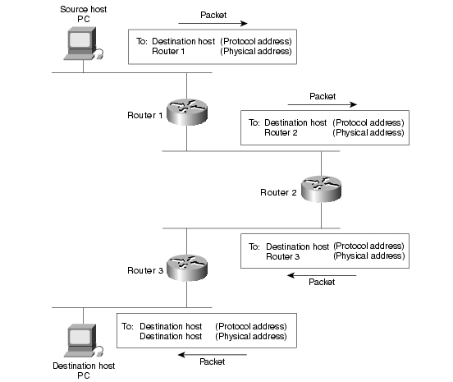
The result of experiment is compared and the efficiency is displayed.
- Comparison
The result of the above mentioned algorithm is compared in the following three properties
  - Link
  - Connectivity
  - And Availability
  - The separate class is written that invokes the two methods and compares the properties. The efficiency ratio is displayed to the user. The efficiency of the delivery is found to be 99% in this simulated mobile adhoc network.

  - UML Diagrams

The Unified Modeling Language (UML) is a standard language for specifying, visualizing, constructing, and documenting the artifacts of software systems, as well as for business modeling and other non-software systems. The UML represents a collection of best engineering practices that have proven successful in the modeling of large and complex systems. The UML is a very important part of developing objects oriented software and the software development process. The UML uses mostly graphical notations to express the design of software projects. Using the UML helps project teams communicate, explore potential designs, and validate the architectural design of the software.

Goals of UML
The primary goals in the design of the UML were:
- Provide users with a ready-to-use, expressive visual modeling language so they can develop and exchange meaningful models.
- Provide extensibility and specialization mechanisms to extend the core concepts.
- Be independent of particular programming languages and development processes.
- Provide a formal basis for understanding the modeling language.
- Encourage the growth of the OO tools market.
- Support higher-level development concepts such as collaborations, frameworks, patterns and components.
- Integrate best practices.

Use Case Diagrams:
A use case is a set of scenarios that describing an interaction between a user and a system. A use case diagram displays the relationship among actors and use cases. The two main components of a use case diagram are use cases and actors.

Class Diagram:
Class diagrams are widely used to describe the types of objects in a system and their relationships. Class diagrams model class structure and contents using design elements such as classes, packages and objects. Class diagrams describe three different perspectives when designing a system, conceptual, specification, and implementation. These perspectives become evident as the diagram is created and help solidify the design. This example is only meant as an introduction to the UML and class diagrams.
Sequence diagrams:
Sequence diagrams demonstrate the behavior of objects in a use case by describing the objects and the messages they pass. The diagrams are read left to right and descending. The example below shows an object of class 1 start the behavior by sending a message to an object of class 2. Messages pass between the different objects until the object of class 1 receives the final message.

Collaboration diagrams:
Collaboration diagrams are also relatively easy to draw. They show the relationship between objects and the order of messages passed between them. The objects are listed as icons and arrows indicate the messages being passed between them. The numbers next to the messages are called sequence numbers. As the name suggests, they show the sequence of the messages as they are passed between the objects. There are many acceptable sequence numbering schemes in UML. A simple 1, 2, 3... format can be used.
State Diagrams:
State diagrams are used to describe the behavior of a system. State diagrams describe all of the possible states of an object as events occur. Each diagram usually represents objects of a single class and tracks the different states of its objects through the system.
Activity Diagrams:
Activity diagrams describe the workflow behavior of a system. Activity diagrams are similar to state diagrams because activities are the state of doing something. The diagrams describe the state of activities by showing the sequence of activities performed. Activity diagrams can show activities that are conditional or parallel.
Use case diagram:

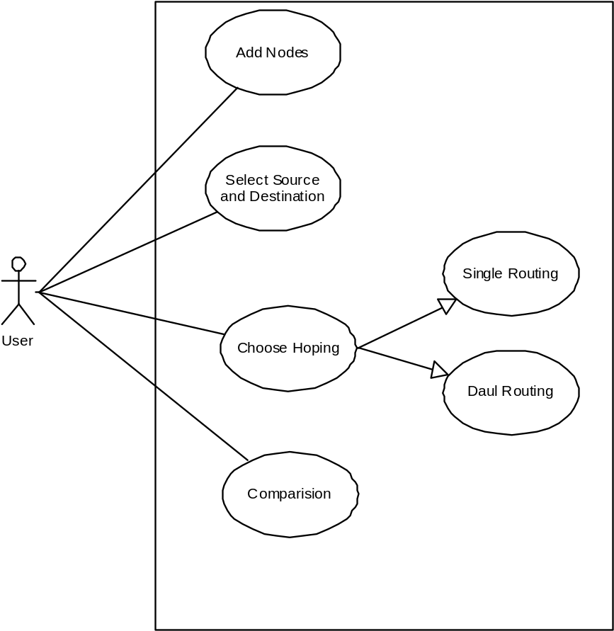

Class diagram:

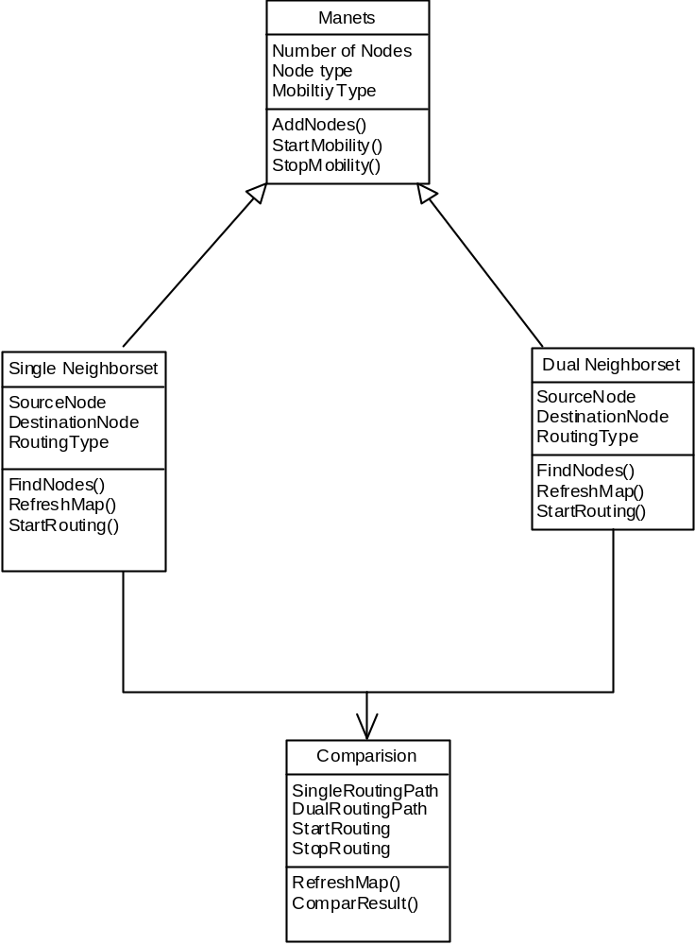

Class Diagram by Code:
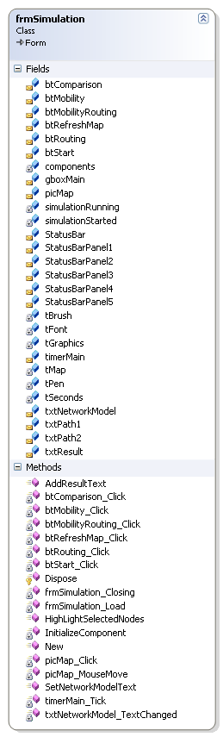

Sequence diagram:

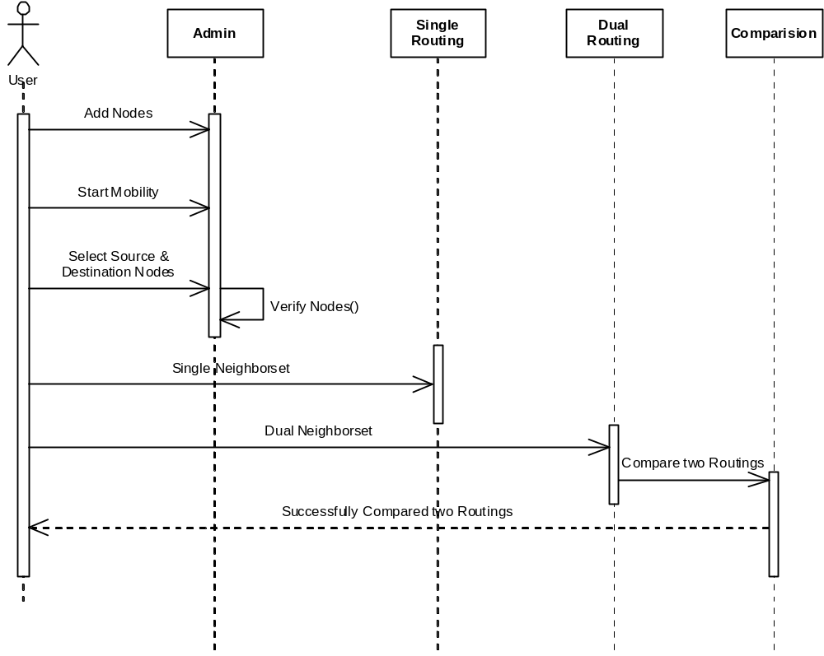

Activity diagram:

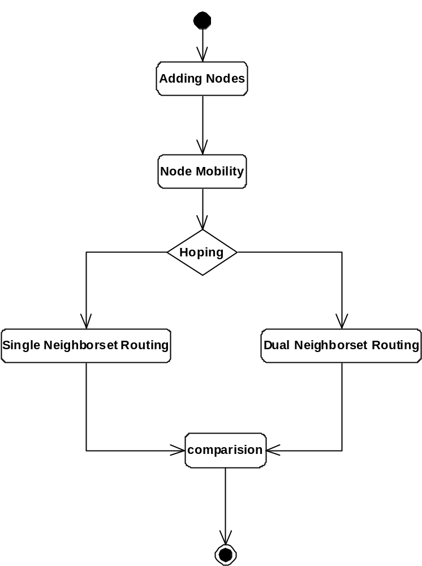

  - Data Dictionary

Data dictionary consists of description of all the data used in the system. It consists of logical characteristics of current systems data stores including name, description, aliases, contents and organization. Data dictionary serves as the basis for identifying database requirements during system design. Data dictionary is a catalog, a depositary of the elements in the system.

The data dictionary is used to manage the details in the large system, to communicate a common meaning for all system elements, to document the future of the system, to locate errors and omission in the system. Data dictionary contains two types of descriptions for the data flowing through the system attributes and tables. Attributes are grouped together to make up the tables. The most fundamental data level is attributes tables are a Set of data items, data related to one another and that collectively describes a component in the system. The description of the attributes consists of data names, data descriptions, aliases, and length and data values. The description of data structures consists sequence relationship, selection relationship, iteration relationship and operational relationship.

7.0. IMPLEMENTATION

  - Methodology:

Waterfall - Software Development Model

Software products are oriented towards customers like any other engineering products. It is either driver by market or it drives the market. Customer Satisfaction was the main aim in the 1980's. Customer Delight is today's logo and Customer Ecstasy is the new buzzword of the new millennium. Products which are not customer oriented have no place in the market although they are designed using the best technology. The front end of the product is as crucial as the internal technology of the product.
A market study is necessary to identify a potential customer’s need. This process is also called as market research. The already existing need and the possible future needs that are combined together for study. A lot of assumptions are made during market study. Assumptions are the very important factors in the development or start of a product's development. The assumptions which are not realistic can cause a nosedive in the entire venture. Although assumptions are conceptual, there should be a move to develop tangible assumptions to move towards a successful product.
Once the Market study is done, the customer's need is given to the Research and Development Department to develop a cost-effective system that could potentially solve customer's needs better than the competitors. Once the system is developed and tested in a hypothetical environment, the development team takes control of it. The development team adopts one of the software development models to develop the proposed system and gives it to the customers.

This model has the following activities.
- Software Requirements Analysis
- Systems Analysis and Design
- Code Generation
- Testing
- Maintenance

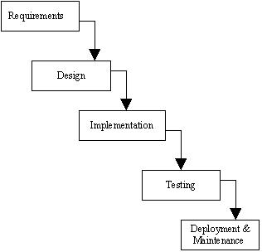

1) Software Requirement Analysis
Software Requirement Analysis is also known as feasibility study. In this requirement analysis phase, the development team visits the customer and studies their system requirement. They examine the need for possible software automation in the given software system. After feasibility study, the development team provides a document that holds the different specific recommendations for the candidate system. It also consists of personnel assignments, costs of the system, project schedule and target dates.
The requirements analysis and information gathering process is intensified and focused specially on software. To understand what type of the programs to be built, the system analyst must study the information domain for the software as well as understand required function, behavior, performance and interfacing. The main purpose of requirement analysis phase is to find the need and to define the problem that needs to be solved.
2) System Analysis and Design
In System Analysis and Design phase, the whole software development process, the overall software structure and its outlay are defined. In case of the client/server processing technology, the number of tiers required for the package architecture, the database design, the data structure design etc are all defined in this phase. After designing part a software development model is created. Analysis and Design are very important in the whole development cycle process. Any fault in the design phase could be very expensive to solve in the software development process. In this phase, the logical system of the product is developed.
3) Code Generation
In Code Generation phase, the design must be decoded into a machine-readable form. If the design of software product is done in a detailed manner, code generation can be achieved without much complication. For generation of code, Programming tools like Compilers, Interpreters, and Debuggers are used. For coding purpose different high level programming languages like C, C++, Pascal and Java are used. The right programming language is chosen according to the type of application.

4) Testing
After code generation phase the software program testing begins. Different testing methods are available to detect the bugs that were committed during the previous phases. A number of testing tools and methods are already available for testing purpose.
5) Maintenance
Software will definitely go through change once when it is delivered to the customer. There are large numbers of reasons for the change. Change could happen due to some unpredicted input values into the system. In addition to this the changes in the system directly have an effect on the software operations. The software should be implemented to accommodate changes that could be happen during the post development period.

  - Technologies Used:

Overview of the .NET Framework
- The .NET Framework is a new computing platform that simplifies application development in the highly distributed environment of the Internet. The .NET Framework is designed to fulfill the following objectives:
- To provide a consistent object-oriented programming environment whether object code is stored and executed locally, executed locally but Internet-distributed, or executed remotely.
- To provide a code-execution environment that minimizes software deployment and versioning conflicts.
- To provide a code-execution environment that guarantees safe execution of code, including code created by an unknown or semi-trusted third party.
- To provide a code-execution environment that eliminates the performance problems of scripted or interpreted environments.
- To make the developer experience consistent across widely varying types of applications, such as Windows-based applications and Web-based applications.
- To build all communication on industry standards to ensure that code based on the .NET Framework can integrate with any other code.
- The .NET Framework has two main components: the common language runtime and the .NET Framework class library. The common language runtime is the foundation of the .NET Framework. You can think of the runtime as an agent that manages code at execution time, providing core services such as memory management, thread management, and remoting, while also enforcing strict type safety and other forms of code accuracy that ensure security and robustness. In fact, the concept of code management is a fundamental principle of the runtime. Code that targets the runtime is known as managed code, while code that does not target the runtime is known as unmanaged code. The class library, the other main component of the .NET Framework, is a comprehensive, object-oriented collection of reusable types that you can use to develop applications ranging from traditional command-line or graphical user interface (GUI) applications to applications based on the latest innovations provided by ASP.NET, such as Web Forms and XML Web services.
- The .NET Framework can be hosted by unmanaged components that load the common language runtime into their processes and initiate the execution of managed code, thereby creating a software environment that can exploit both managed and unmanaged features. The .NET Framework not only provides several runtime hosts, but also supports the development of third-party runtime hosts.
- For example, ASP.NET hosts the runtime to provide a scalable, server-side environment for managed code. ASP.NET works directly with the runtime to enable Web Forms applications and XML Web services, both of which are discussed later in this topic.
- Internet Explorer is an example of an unmanaged application that hosts the runtime (in the form of a MIME type extension). Using Internet Explorer to host the runtime enables you to embed managed components or Windows Forms controls in HTML documents. Hosting the runtime in this way makes managed mobile code (similar to Microsoft® ActiveX® controls) possible, but with significant improvements that only managed code can offer, such as semi-trusted execution and secure isolated file storage.
- Features of the Common Language Runtime
- The common language runtime manages memory, thread execution, code execution, code safety verification, compilation, and other system services. These features are intrinsic to the managed code that runs on the common language runtime.
- With regards to security, managed components are awarded varying degrees of trust, depending on a number of factors that include their origin (such as the Internet, enterprise network, or local computer). This means that a managed component might or might not be able to perform file-access operations, registry-access operations, or other sensitive functions, even if it is being used in the same active application.
- The runtime enforces code access security. For example, users can trust that an executable embedded in a Web page can play an animation on screen or sing a song, but cannot access their personal data, file system, or network. The security features of the runtime thus enable legitimate Internet-deployed software to be exceptionally feature rich.
- The runtime also enforces code robustness by implementing a strict type- and code-verification infrastructure called the common type system (CTS). The CTS ensures that all managed code is self-describing. The various Microsoft and third-party language compilers generate managed code that conforms to the CTS. This means that managed code can consume other managed types and instances, while strictly enforcing type fidelity and type safety.
In addition, the managed environment of the runtime eliminates many common software issues. For example, the runtime automatically handles object layout and manages references to objects, releasing them when they are no longer being used. This automatic memory management resolves the two most common application errors, memory leaks and invalid memory references.
The runtime also accelerates developer productivity. For example, programmers can write applications in their development language of choice, yet take full advantage of the runtime, the class library, and components written in other languages by other developers. Any compiler vendor who chooses to target the runtime can do so. Language compilers that target the .NET Framework make the features of the .NET Framework available to existing code written in that language, greatly easing the migration process for existing applications.
While the runtime is designed for the software of the future, it also supports software of today and yesterday. Interoperability between managed and unmanaged code enables developers to continue to use necessary COM components and DLLs.
The runtime is designed to enhance performance. Although the common language runtime provides many standard runtime services, managed code is never interpreted. A feature called just-in-time (JIT) compiling enables all managed code to run in the native machine language of the system on which it is executing. Meanwhile, the memory manager removes the possibilities of fragmented memory and increases memory locality-of-reference to further increase performance.
Finally, the runtime can be hosted by high-performance, server-side applications, such as Microsoft® SQL Server™ and Internet Information Services (IIS). This infrastructure enables you to use managed code to write your business logic, while still enjoying the superior performance of the industry's best enterprise servers that support runtime hosting.
Common Type System
The common type system defines how types are declared, used, and managed in the runtime, and is also an important part of the runtime's support for cross-language integration. The common type system performs the following functions:
Establishes a framework that enables cross-language integration, type safety, and high performance code execution.
Provides an object-oriented model that supports the complete implementation of many programming languages.
Defines rules that languages must follow, which helps ensure that objects written in different languages can interact with each other.
In This Section Common Type System Overview
Describes concepts and defines terms relating to the common type system.
Type Definitions

Describes user-defined types.

Type Members
Describes events, fields, nested types, methods, and properties, and concepts such as member overloading, overriding, and inheritance.

Value Types
Describes built-in and user-defined value types.

Classes
Describes the characteristics of common language runtime classes.
Delegates
Describes the delegate object, which is the managed alternative to unmanaged function pointers.
Arrays
Describes common language runtime array types.

Interfaces
Describes characteristics of interfaces and the restrictions on interfaces imposed by the common language runtime.
Pointers
Describes managed pointers, unmanaged pointers, and unmanaged function pointers.
Related Sections
. NET Framework Class Library
Provides a reference to the classes, interfaces, and value types included in the Microsoft .NET Framework SDK.
Common Language Runtime
Describes the run-time environment that manages the execution of code and provides application development services.
Cross-Language Interoperability
The common language runtime provides built-in support for language interoperability. However, this support does not guarantee that developers using another programming language can use code you write. To ensure that you can develop managed code that can be fully used by developers using any programming language, a set of language features and rules for using them called the Common Language Specification (CLS) has been defined. Components that follow these rules and expose only CLS features are considered CLS-compliant.
This section describes the common language runtime's built-in support for language interoperability and explains the role that the CLS plays in enabling guaranteed cross-language interoperability. CLS features and rules are identified and CLS compliance is discussed.
In This Section
Language Interoperability
Describes built-in support for cross-language interoperability and introduces the Common Language Specification.

What is the Common Language Specification?
Explains the need for a set of features common to all languages and identifies CLS rules and features.

Writing CLS-Compliant Code
Discusses the meaning of CLS compliance for components and identifies levels of CLS compliance for tools.

Common Type System
Describes how types are declared, used, and managed by the common language runtime.

Metadata and Self-Describing Components
Explains the common language runtime's mechanism for describing a type and storing that information with the type itself.
. NET Framework Class Library
The .NET Framework class library is a collection of reusable types that tightly integrate with the common language runtime. The class library is object oriented, providing types from which your own managed code can derive functionality. This not only makes the .NET Framework types easy to use, but also reduces the time associated with learning new features of the .NET Framework. In addition, third-party components can integrate seamlessly with classes in the .NET Framework.
For example, the .NET Framework collection classes implement a set of interfaces that you can use to develop your own collection classes. Your collection classes will blend seamlessly with the classes in the .NET Framework.

ADO.NET Overview
ADO.NET is an evolution of the ADO data access model that directly addresses customer requirements for developing scalable applications. It was designed specifically for the web with scalability, statelessness, and XML in mind.
ADO.NET uses some ADO objects, such as the Connection and Command objects, and also introduces new objects. Key new ADO.NET objects include the Dataset, Data Reader, and Data Adapter.
The important distinction between this evolved stage of ADO.NET and previous data architectures is that there exists an object -- the Dataset -- that is separate and distinct from any data stores. Because of that, the Dataset functions as a standalone entity. You can think of the DataSet as an always disconnected record set that knows nothing about the source or destination of the data it contains. Inside a Dataset, much like in a database, there are tables, columns, relationships, constraints, views, and so forth.
A Data Adapter is the object that connects to the database to fill the Dataset. Then, it connects back to the database to update the data there, based on operations performed while the Dataset held the data. In the past, data processing has been primarily connection-based. Now, in an effort to make multi-tiered apps more efficient, data processing is turning to a message-based approach that revolves around chunks of information. At the center of this approach is the Data Adapter, which provides a bridge to retrieve and save data between a Dataset and its source data store. It accomplishes this by means of requests to the appropriate SQL commands made against the data store.
The XML-based Dataset object provides a consistent programming model that works with all models of data storage: flat, relational, and hierarchical. It does this by having no 'knowledge' of the source of its data, and by representing the data that it holds as collections and data types. No matter what the source of the data within the Dataset is, it is manipulated through the same set of standard APIs exposed through the Dataset and its subordinate objects.
While the Dataset has no knowledge of the source of its data, the managed provider has detailed and specific information. The role of the managed provider is to connect, fill, and persist the Dataset to and from data stores. The OLE DB and SQL Server .NET Data Providers (System.Data.OleDb and System.Data.SqlClient) that are part of the .Net Framework provide four basic objects: the Command, Connection, DataReader and DataAdapter. In the remaining sections of this document, we'll walk through each part of the DataSet and the OLE DB/SQL Server .NET Data Providers explaining what they are, and how to program against them.
The following sections will introduce you to some objects that have evolved, and some that are new. These objects are:
- Connections. For connection to and managing transactions against a database.
- Commands. For issuing SQL commands against a database.
- DataReaders. For reading a forward-only stream of data records from a SQL Server data source.
- DataSets. For storing, remoting and programming against flat data, XML data and relational data.
- DataAdapters. For pushing data into a DataSet, and reconciling data against a database.
When dealing with connections to a database, there are two different options: SQL Server .NET Data Provider (System.Data.SqlClient) and OLE DB .NET Data Provider (System.Data.OleDb). In these samples we will use the SQL Server .NET Data Provider. These are written to talk directly to Microsoft SQL Server. The OLE DB .NET Data Provider is used to talk to any OLE DB provider (as it uses OLE DB underneath).
Connections
Connections are used to 'talk to' databases, and are respresented by provider-specific classes such as SQLConnection. Commands travel over connections and resultsets are returned in the form of streams which can be read by a DataReader object, or pushed into a DataSet object.
Commands
Commands contain the information that is submitted to a database, and are represented by provider-specific classes such as SQLCommand. A command can be a stored procedure call, an UPDATE statement, or a statement that returns results. You can also use input and output parameters, and return values as part of your command syntax. The example below shows how to issue an INSERT statement against the Northwind database.
DataReaders
The DataReader object is somewhat synonymous with a read-only/forward-only cursor over data. The DataReader API supports flat as well as hierarchical data. A DataReader object is returned after executing a command against a database. The format of the returned DataReader object is different from a recordset. For example, you might use the DataReader to show the results of a search list in a web page.
DataSets and DataAdapters
DataSets
The DataSet object is similar to the ADO Recordset object, but more powerful, and with one other important distinction: the DataSet is always disconnected. The DataSet object represents a cache of data, with database-like structures such as tables, columns, relationships, and constraints. However, though a DataSet can and does behave much like a database, it is important to remember that DataSet objects do not interact directly with databases, or other source data. This allows the developer to work with a programming model that is always consistent, regardless of where the source data resides. Data coming from a database, an XML file, from code, or customer input can all be placed into DataSet objects. Then, as changes are made to the DataSet they can be tracked and verified before updating the source data. The GetChanges method of the DataSet object actually creates a second DatSet that contains only the changes to the data. This DataSet is then used by a DataAdapter (or other objects) to update the original data source.
The DataSet has many XML characteristics, including the ability to produce and consume XML data and XML schemas. XML schemas can be used to describe schemas interchanged via WebServices. In fact, a DataSet with a schema can actually be compiled for type safety and statement completion.
DataAdapters (OLEDB/SQL)
The DataAdapter object works as a bridge between the DataSet and the source data. Using the provider-specific SqlDataAdapter (along with its associated SqlCommand and SqlConnection) can increase overall performance when working with a Microsoft SQL Server databases. For other OLE DB-supported databases, you would use the OleDbDataAdapter object and its associated OleDbCommand and OleDbConnection objects.
The DataAdapter object uses commands to update the data source after changes have been made to the DataSet. Using the Fill method of the DataAdapter calls the SELECT command; using the Update method calls the INSERT, UPDATE or DELETE command for each changed row. You can explicitly set these commands in order to control the statements used at runtime to resolve changes, including the use of stored procedures. For ad-hoc scenarios, a CommandBuilder object can generate these at run-time based upon a select statement. However, this run-time generation requires an extra round-trip to the server in order to gather required metadata, so explicitly providing the INSERT, UPDATE, and DELETE commands at design time will result in better run-time performance.
- ADO.NET is the next evolution of ADO for the .Net Framework.
- ADO.NET was created with n-Tier, statelessness and XML in the forefront. Two new objects, the DataSet and DataAdapter, are provided for these scenarios.
- ADO.NET can be used to get data from a stream, or to store data in a cache for updates.
- There is a lot more information about ADO.NET in the documentation.
- Remember, you can execute a command directly against the database in order to do inserts, updates, and deletes. You don't need to first put data into a DataSet in order to insert, update, or delete it.
- Also, you can use a DataSet to bind to the data, move through the data, and navigate data relationships
ASP.NET

Server Application Development
Server-side applications in the managed world are implemented through runtime hosts. Unmanaged applications host the common language runtime, which allows your custom managed code to control the behavior of the server. This model provides you with all the features of the common language runtime and class library while gaining the performance and scalability of the host server.
The following illustration shows a basic network schema with managed code running in different server environments. Servers such as IIS and SQL Server can perform standard operations while your application logic executes through the managed code.

SERVER-SIDE MANAGED CODE

ASP.NET is the hosting environment that enables developers to use the .NET Framework to target Web-based applications. However, ASP.NET is more than just a runtime host; it is a complete architecture for developing Web sites and Internet-distributed objects using managed code. Both Web Forms and XML Web services use IIS and ASP.NET as the publishing mechanism for applications, and both have a collection of supporting classes in the .NET Framework.
XML Web services, an important evolution in Web-based technology, are distributed, server-side application components similar to common Web sites. However, unlike Web-based applications, XML Web services components have no UI and are not targeted for browsers such as Internet Explorer and Netscape Navigator. Instead, XML Web services consist of reusable software components designed to be consumed by other applications, such as traditional client applications, Web-based applications, or even other XML Web services. As a result, XML Web services technology is rapidly moving application development and deployment into the highly distributed environment of the Internet.
If you have used earlier versions of ASP technology, you will immediately notice the improvements that ASP.NET and Web Forms offers. For example, you can develop Web Forms pages in any language that supports the .NET Framework. In addition, your code no longer needs to share the same file with your HTTP text (although it can continue to do so if you prefer). Web Forms pages execute in native machine language because, like any other managed application, they take full advantage of the runtime. In contrast, unmanaged ASP pages are always scripted and interpreted. ASP.NET pages are faster, more functional, and easier to develop than unmanaged ASP pages because they interact with the runtime like any managed application.
The .NET Framework also provides a collection of classes and tools to aid in development and consumption of XML Web services applications. XML Web services are built on standards such as SOAP (a remote procedure-call protocol), XML (an extensible data format), and WSDL ( the Web Services Description Language). The .NET Framework is built on these standards to promote interoperability with non-Microsoft solutions.
For example, the Web Services Description Language tool included with the .NET Framework SDK can query an XML Web service published on the Web, parse its WSDL description, and produce C# or Visual Basic source code that your application can use to become a client of the XML Web service. The source code can create classes derived from classes in the class library that handle all the underlying communication using SOAP and XML parsing. Although you can use the class library to consume XML Web services directly, the Web Services Description Language tool and the other tools contained in the SDK facilitate your development efforts with the .NET Framework.
If you develop and publish your own XML Web service, the .NET Framework provides a set of classes that conform to all the underlying communication standards, such as SOAP, WSDL, and XML. Using those classes enables you to focus on the logic of your service, without concerning yourself with the communications infrastructure required by distributed software development.
Finally, like Web Forms pages in the managed environment, your XML Web service will run with the speed of native machine language using the scalable communication of IIS.

ACTIVE SERVER PAGES.NET
ASP.NET is a programming framework built on the common language runtime that can be used on a server to build powerful Web applications. ASP.NET offers several important advantages over previous Web development models:
- Enhanced Performance. ASP.NET is compiled common language runtime code running on the server. Unlike its interpreted predecessors, ASP.NET can take advantage of early binding, just-in-time compilation, native optimization, and caching services right out of the box. This amounts to dramatically better performance before you ever write a line of code.
- World-Class Tool Support. The ASP.NET framework is complemented by a rich toolbox and designer in the Visual Studio integrated development environment. WYSIWYG editing, drag-and-drop server controls, and automatic deployment are just a few of the features this powerful tool provides.
- Power and Flexibility. Because ASP.NET is based on the common language runtime, the power and flexibility of that entire platform is available to Web application developers. The .NET Framework class library, Messaging, and Data Access solutions are all seamlessly accessible from the Web. ASP.NET is also language-independent, so you can choose the language that best applies to your application or partition your application across many languages. Further, common language runtime interoperability guarantees that your existing investment in COM-based development is preserved when migrating to ASP.NET.
- Simplicity. ASP.NET makes it easy to perform common tasks, from simple form submission and client authentication to deployment and site configuration. For example, the ASP.NET page framework allows you to build user interfaces that cleanly separate application logic from presentation code and to handle events in a simple, Visual Basic - like forms processing model. Additionally, the common language runtime simplifies development, with managed code services such as automatic reference counting and garbage collection.
- Manageability. ASP.NET employs a text-based, hierarchical configuration system, which simplifies applying settings to your server environment and Web applications. Because configuration information is stored as plain text, new settings may be applied without the aid of local administration tools. This "zero local administration" philosophy extends to deploying ASP.NET Framework applications as well. An ASP.NET Framework application is deployed to a server simply by copying the necessary files to the server. No server restart is required, even to deploy or replace running compiled code.
- Scalability and Availability. ASP.NET has been designed with scalability in mind, with features specifically tailored to improve performance in clustered and multiprocessor environments. Further, processes are closely monitored and managed by the ASP.NET runtime, so that if one misbehaves (leaks, deadlocks), a new process can be created in its place, which helps keep your application constantly available to handle requests.
- Customizability and Extensibility. ASP.NET delivers a well-factored architecture that allows developers to "plug-in" their code at the appropriate level. In fact, it is possible to extend or replace any subcomponent of the ASP.NET runtime with your own custom-written component. Implementing custom authentication or state services has never been easier.
- Security. With built in Windows authentication and per-application configuration, you can be assured that your applications are secure.

LANGUAGE SUPPORT
The Microsoft .NET Platform currently offers built-in support for three languages: C#, Visual Basic, and JScript.

WHAT IS ASP.NET WEB FORMS?
The ASP.NET Web Forms page framework is a scalable common language runtime programming model that can be used on the server to dynamically generate Web pages.
Intended as a logical evolution of ASP (ASP.NET provides syntax compatibility with existing pages), the ASP.NET Web Forms framework has been specifically designed to address a number of key deficiencies in the previous model. In particular, it provides:
- The ability to create and use reusable UI controls that can encapsulate common functionality and thus reduce the amount of code that a page developer has to write.
- The ability for developers to cleanly structure their page logic in an orderly fashion (not "spaghetti code").
- The ability for development tools to provide strong WYSIWYG design support for pages (existing ASP code is opaque to tools).

ASP.NET Web Forms pages are text files with an .aspx file name extension. They can be deployed throughout an IIS virtual root directory tree. When a browser client requests .aspx resources, the ASP.NET runtime parses and compiles the target file into a .NET Framework class. This class can then be used to dynamically process incoming requests. (Note that the .aspx file is compiled only the first time it is accessed; the compiled type instance is then reused across multiple requests).
An ASP.NET page can be created simply by taking an existing HTML file and changing its file name extension to .aspx (no modification of code is required). For example, the following sample demonstrates a simple HTML page that collects a user's name and category preference and then performs a form postback to the originating page when a button is clicked:
ASP.NET provides syntax compatibility with existing ASP pages. This includes support for <% %> code render blocks that can be intermixed with HTML content within an .aspx file. These code blocks execute in a top-down manner at page render time.

CODE-BEHIND WEB FORMS
ASP.NET supports two methods of authoring dynamic pages. The first is the method shown in the preceding samples, where the page code is physically declared within the originating .aspx file. An alternative approach--known as the code-behind method--enables the page code to be more cleanly separated from the HTML content into an entirely separate file.

INTRODUCTION TO ASP.NET SERVER CONTROLS

In addition to (or instead of) using <% %> code blocks to program dynamic content, ASP.NET page developers can use ASP.NET server controls to program Web pages. Server controls are declared within an .aspx file using custom tags or intrinsic HTML tags that contain a runat="server" attributes value. Intrinsic HTML tags are handled by one of the controls in the System.Web.UI.HtmlControls namespace. Any tag that doesn't explicitly map to one of the controls is assigned the type of System.Web.UI.HtmlControls.HtmlGenericControl.
Server controls automatically maintain any client-entered values between round trips to the server. This control state is not stored on the server (it is instead stored within an <input type="hidden"> form field that is round-tripped between requests). Note also that no client-side script is required.
In addition to supporting standard HTML input controls, ASP.NET enables developers to utilize richer custom controls on their pages. For example, the following sample demonstrates how the <asp:adrotator> control can be used to dynamically display rotating ads on a page.
- ASP.NET Web Forms provide an easy and powerful way to build dynamic Web UI.
- ASP.NET Web Forms pages can target any browser client (there are no script library or cookie requirements).
- ASP.NET Web Forms pages provide syntax compatibility with existing ASP pages.
- ASP.NET server controls provide an easy way to encapsulate common functionality.
- ASP.NET ships with 45 built-in server controls. Developers can also use controls built by third parties.
- ASP.NET server controls can automatically project both uplevel and downlevel HTML.
- ASP.NET templates provide an easy way to customize the look and feel of list server controls.
- ASP.NET validation controls provide an easy way to do declarative client or server data validation.

8.0. TESTING

  - Introduction

Software testing is a critical element of software quality assurance and represents the ultimate reviews of specification, design and coding. Testing represents an interesting anomaly for the software. During earlier definition and development phases, it was attempted to build software from an abstract concept to a tangible implementation. No system is error free because it is so till the next error drops up during any phase of the development or usage of the product. A sincere effort however needs to be put to bring out a product that is satisfactory.
The testing phase involves the testing of development system using various data. Preparation of the test data plays a vital role in system testing. After preparing the test data, the system under study was tested using those data. While testing the system, by using the test data, errors were found and corrected by using the following testing steps and corrections were also noted for future use. Thus, a series of testing is performed on the proposed system before the system is ready for implementation.

TEST PLAN:

The importance of software testing and its implications cannot be overemphasized. Software testing is a critical element of Software Quality Assurance and represents the ultimate review of the specifications, design and coding.

Software Testing:

As the coding is completed according to the requirement we have to test the quality of the software. Software testing is a critical element of the software quality assurance and represents the ultimate review of specification, design and coding. Although testing is to uncover the errors in the software functions appear to be working as per the specification, those performance requirements appear top have been met. In addition, data collected as testing is conducted provide a good indication of software reliability and some indications of software quality as a whole. To assure the software quality we conduct both white box testing and black box testing.

White box testing

White box testing is a test case design method that uses the control structure of the procedural designs to derive test cases. As we are using a non procedural language, there is very small scope for the white box testing. Whenever it is necessary, there the control structures are tested and successfully passed all the control structures with a very minimum errors.

Black box testing

It focuses on the functional requirements to the software. It enables to derive sets of input conditions that will fully exercise all functional requirements for a program. The Black box testing finds almost all errors. It finds some interface errors and errors in accessing the database and some performance errors. In Black box testing we use two techniques equivalence partitioning the boundary volume analyzing technique.

System testing:
It is designated to uncover weakness that was not detected in the earlier tests. The total system is tested for recovery and fallback after various major failures to ensure that no data are lost. an acceptance test is done to validity and reliability of the system. The philosophy behind the testing is to find error in project. There are many test cases designed with this in mond.The flow of testing is as follows

- Code Testing :
Specification testing is done to check if the program does with it should do and how it should behave under various condition or combinations and submitted for processing in the system and it is checked if any overlaps occur during the processing. This strategy examines the logic of the program. Here only syntax of the code is tested. In code testing syntax errors are corrected, to ensure that the code is perfect.

- Unit Testing :

The first level of testing is called unit testing. Here different modules are tested against the specification produced running the design of the modules. Unit testing is done to test the working of individual modules with test oracles. Unit testing comprises a set of tests performed by an individual programmer prior to integration of the units into a large system. A program unit is usually small enough that the programmer who developed it can test it in a great detail. Unit testing focuses first on the modules to locate errors. These errors are verified and corrected so that the unit perfectly fits to the project.

- System Testing :

The next level of testing is system testing and acceptance testing. This testing is done to check if the system has met its requirements and to find the external behavior of the system. System testing involves two kinds of activities.

- Integration testing
- Acceptance testing

The next level of testing is called the Integration testing. In this many tested modules are combined into subsystems, which were then tested. Test case data is prepared to check the control flow of all the modules and to exhaust all possible inputs to the program. Situations like treating the modules when there is no data entered in the test box is also tested.

This testing strategy dictates the order in which modules must be available, and exerts strong influence on the order in which the modules must be written, debugged and unit tested. In integration testing, all modules on which unit testing\g is performed are integrated together and tested.

Acceptance testing:

This testing is performed finally by user to demonstrate that the implemented system satisfies its requirements. The user gives various inputs to get required outputs.

Specification Testing:

This is done to check if the program does what it should do and how it should behave under various conditions or combination and submitted for processing in the system and it is checked if any overlaps occur during the processing.

Performance Time Testing:

This is done to determine how long it takes to accept and respond i.e., the total time for processing when it has to handle quite a large number of records. It is essential to check the exception speed of the system, which runs well with only a handful of test transactions. Such systems might be slow when fully loaded. So testing is done by providing large number of data for processing. A system testing is designed to uncover weaknesses that were not detected in the earlier tests.

The total system is tested for recovery and fall back after various major failures to ensure that no data is lost during an emergency, an acceptance test is done to ensure about the validity and reliability of the system.

  - Test Cases

Name of the Test Case:
Test Case # | Test Case Description | Expected Results | Pass / Fail | Actual Results
01 | If the value is not entered in the textbox and click on ok | Then it should provide an error. | Pass | It has shown an error.
02. | If the value in the textbox is entered is not an integer and click on ok | Then it should provide an error | Pass | It has provided an error message to enter number.
03. | The value in the textbox is given as an number and click on ok | It shall accept the value | Pass | It has accepted the value.
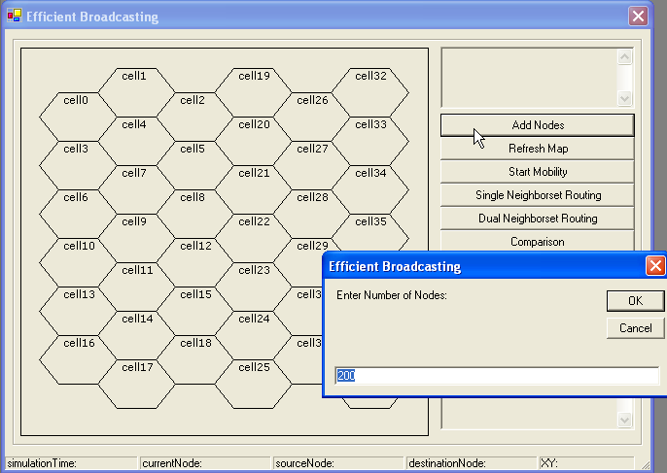

9.0. MAINTENANCE

The objectives of this maintenance work are to make sure that the system gets into work all time without any bug. Provision must be for environmental changes which may affect the computer or software system. This is called the maintenance of the system. Nowadays there is the rapid change in the software world. Due to this rapid change, the system should be capable of adapting these changes. In our project the process can be added without affecting other parts of the system. Maintenance plays a vital role. The system liable to accept any modification after its implementation. This system has been designed to favor all new changes. Doing this will not affect the system’s performance or its accuracy.
10.0. FUTURE ENHANCEMENT

The project has covered almost all the requirements. Further requirements and improvements can easily be done since the coding is mainly structured or modular in nature. Improvements can be appended by changing the existing modules or adding new modules. One important development that can be added to the project in future is file level backup, which is presently done for folder level.
- The size of the database increases day-by-day, increasing the load on the database back up and data maintenance activity.
- Training for simple computer operations is necessary for the users working on the system.
- We have to improve its GUI part to provide more attractive features to the user.
11.0. CONCLUSION

This project describes the proposed a mobility management method based on the use of two transmission ranges. Using this mechanism, we have also extended Wu and Dai’s coverage condition to a dynamic environment where network topology is allowed to change, even during the broadcast process. In addition, connectivity, link availability, and consistency issues related to neighborhood information of different nodes have also been addressed. The proposed scheme can also be extended to provide mobility management for other activities, such as topology control in MANETs.
The constraint used on r2 - r1 in this paper is conservative. Our probabilistic analysis suggests that high delivery ratio can still be achieved with a larger r1. Simulation results
show that the proposed method and the dual neighbor set enhancement achieve good balance between delivery ratio and broadcast redundancy by adjusting the value of r1
based on the network mobility level. A future extension would be automatic buffer zone width adjustment that adapts to the neighborhood mobility level.
12.0. BIBLIOGRAPHY

1 Steven Holzner , “Visual Basic .Net Programming “ Black Book -
Dream Tech Press, New Delhi
2. Visual Basic Programmer’s Cook Book
3. Software Engineering By Roger Pressman
4. Lee “ Introduction to System Analysis and Design”
Galgotia Book Source Publications

13.0. SCREENS/ FORMS
Appendix

